Messier objects
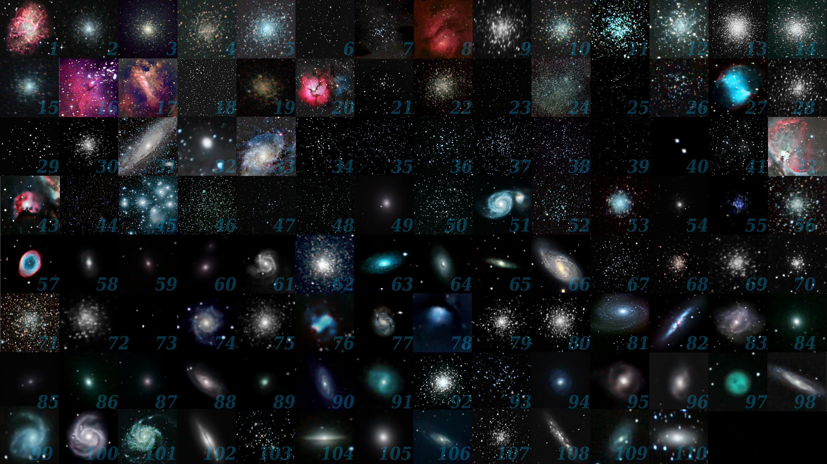

Galaxie-mlhoviny (DSO)/ Hvězdokupy
- údaje před názvem shv. – Distance (tis sv. let), údaj za názvem shv. – Mag.

Galxies

M1 | NGC 1952 | Crab Nebula | 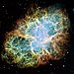 | Supernova remnant | 4.9–8.1 | Taurus | 8.4 | 05^{h} 34^{m} 31.94^{s} | +22° 00′ 52.2″

M8 | NGC 6523 | Lagoon Nebula | 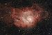 | Nebula with cluster | 4.1 | Sagittarius | 6.0 | 18^{h} 03^{m} 37^{s} | −24° 23′ 12″
M16 | NGC 6611 | Eagle Nebula | 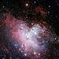 | H II region nebula with cluster | 7 | Serpens | 6.0 | 18h 18m 48s | −13° 49′
M17 | NGC 6618 | Omega, Swan, Horseshoe, or Lobster Nebula | 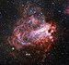 | H II region nebula with cluster | 5–6 | Sagittarius | 6.0 | 18h 20m 26s | −16° 10′ 36″
M20 | NGC 6514 | Trifid Nebula | 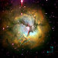28´ | H II region nebula with cluster | 5.2 | Sagittarius | 6.3 | 18h 02m 23s | −23° 01′ 48″
M24 | IC 4715 | Small Sagittarius Star Cloud | 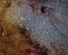 | Milky Way star cloud | ~10 | Sagittarius | 2.5 | 18h 17m | −18° 33′
M27 | NGC 6853 | Dumbbell Nebula | 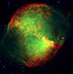 | Planetary nebula | 1.148–1.52 | Vulpecula | 7.5 | 19h 59m 36.340s | +22° 43′ 16.09″
M31 | NGC 224 | Andromeda Galaxy | 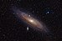 | Spiral galaxy | 2,430–2,650 | Andromeda | 3.4 | 00h 42m 44.3s | +41° 16′ 9″
M32 | NGC 221 | – | 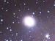 | Dwarf elliptical galaxy | 2,410–2,570 | Andromeda | 8.1 | 00h 42m 41.8s | +40° 51′ 55″
M33 | NGC 598 | Triangulum Galaxy | 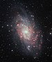 | Spiral galaxy | 2,380–3,070 | Triangulum | 5.7 | 01h 33m 50.02s | +30° 39′ 36.7″
M42 | NGC 1976 | Orion Nebula | 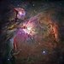 | H II region nebula | 1.324–1.364 | Orion | 4.0 | 05h 35m 17.3 | −05° 23′ 28″
M43 | NGC 1982 | De Mairan's Nebula | 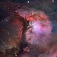 | H II region nebula (part of the Orion Nebula) | 1.6 | Orion | 9.0 | 05h 35.6m | −05° 16′
M49 | NGC 4472 | – | 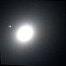 | Elliptical galaxy | 53,600–58,200 | Virgo | 9.4 | 12h 29m 46.7s | +08° 00′ 02″
M51 | NGC 5194, NGC 5195 | Whirlpool Galaxy | 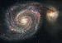 | Spiral galaxy | 19,000–27,000 | Canes Venatici | 8.4 | 13h 29m 52.7s | +47° 11′ 43″
M57 | NGC 6720 | Ring Nebula | 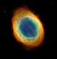 203 x 230´ | Planetary nebula | 1.6–3.8 | Lyra | 8.8 | 18h 53m 35.079s | +33° 01′ 45.03″
M58 | NGC 4579 | – | 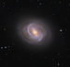 | Barred Spiral galaxy | ~63,000 | Virgo | 10.5 | 12h 37m 43.5s | +11° 49′ 05″
M59 | NGC 4621 | – |  | Elliptical galaxy | 55,000–65,000 | Virgo | 10.6 | 12h 42m 02.3s | +11° 38′ 49″
M60 | NGC 4649 | – | 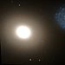 | Elliptical galaxy | 51,000–59,000 | Virgo | 9.8 | 12h 43m 39.6s | +11° 33′ 09″
M61 | NGC 4303 | – | 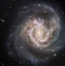 | Spiral galaxy  Dist.. 23 Mly (7.1 ± 1.2 Mpc)/ Redshift 0.001544  AM 8.4  AD 11′.2 × 6′.9  S/d 76 000 ly | 50,200–54,800 | Virgo | 10.2 | 12h 21m 54.9s | +04° 28′ 25″
M63 | NGC 5055 | Sunflower Galaxy | 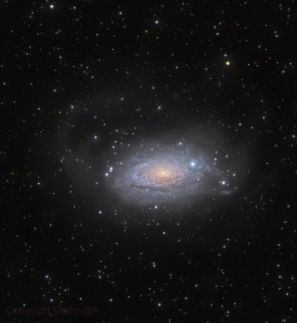 | Spiral galaxy  484 km/ s (30 mly/ 9 Mpc)  13 x 7´  V 9,3 | 37,000 | Canes Venatici | 9.3 | 13h 15m 49.3s | +42° 01′ 45″
M64 | NGC 4826 | Black Eye Galaxy | 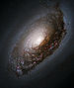 | Spiral galaxy | 22,000–26,000 | Coma Berenices | 9.4 | 12h 56m 43.7s | +21° 40′ 58″
M65 | NGC 3623 | Leo Triplet | 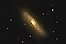 | Barred Spiral galaxy | 41,000–42,000 | Leo | 10.3 | 11h 18m 55.9s | +13° 05′ 32″
M66 | NGC 3627 | Leo Triplet | 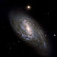 | Barred Spiral galaxy | 31,000–41,000 | Leo | 8.9 | 11h 20m 15.0s | +12° 59′ 30″
M74 | NGC 628 | Phantom Galaxy[91] | 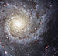 | Spiral galaxy | 24,000–36,000 | Pisces | 10.0 | 01h 36m 41.8s | +15° 47′ 01″
M76 | NGC 650, NGC 651 | Little Dumbbell Nebula | 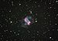 | Planetary nebula | 2.5 | Perseus | 10.1 | 01h 42.4m | +51° 34′ 31″
M77 | NGC 1068 | Cetus A | 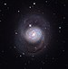 | Spiral galaxy | 47,000 | Cetus | 9.6 | 02h 42m 40.7s | −00° 00′ 48″
M78 | NGC 2068 | – | 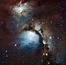 | Diffuse nebula | 1.6 | Orion | 8.3 | 05h 46m 46.7s | +00° 00′ 50″
M81 | NGC 3031 | Bode's Galaxy | 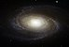 | Spiral galaxy | 11,400–12,200 | Ursa Major | 6.9 | 09h 55m 33.2s | +69° 3′ 55″
M82 | NGC 3034 | Cigar Galaxy | 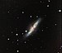 | Starburst galaxy | 10,700–12,300 | Ursa Major | 8.4 | 09h 55m 52.2s | +69° 40′ 47″
M83 | NGC 5236 | Southern Pinwheel Galaxy | 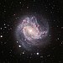 | Barred Spiral galaxy | 14,700 | Hydra | 7.5 | 13h 37m 00.9s | −29° 51′ 57″
M84 | NGC 4374 | – | 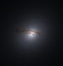 | Lenticular galaxy | 57,000–63,000 | Virgo | 10.1 | 12h 25m 03.7s | +12° 53′ 13″
M85 | NGC 4382 | – | 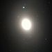 | Lenticular galaxy | 56,000–64,000 | Coma Berenices | 10.0 | 12h 25m 24.0s | +18° 11′ 28″
M86 | NGC 4406 | – | 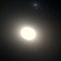 | Lenticular galaxy | 49,000–55,000 | Virgo | 9.8 | 12h 26m 11.7s | +12° 56′ 46″
M87 | NGC 4486 | Virgo A | 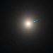 | Elliptical galaxy | 51,870–55,130 | Virgo | 9.6 | 12h 30m 49.42338s | +12° 23′ 28.0439″
M88 | NGC 4501 | – | 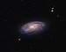 | Spiral galaxy | 39,000–56,000 | Coma Berenices | 10.4 | 12h 31m 59.2s | +14° 25′ 14″
M89 | NGC 4552 | – |  | Elliptical galaxy | 47,000–53,000 | Virgo | 10.7 | 12h 35m 39.8s | +12° 33′ 23″
M90 | NGC 4569 | – | 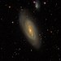 | Spiral galaxy | 55,900–61,500 | Virgo | 10.3 | 12h 36m 49.8s | +13° 09′ 46″
M91 | NGC 4548 | – | 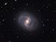 | Barred Spiral galaxy | 47,000–79,000 | Coma Berenices | 11.0 | 12h 35m 26.4s | +14° 29′ 47″
M94 | NGC 4736 | Croc's Eye or Cat's Eye | 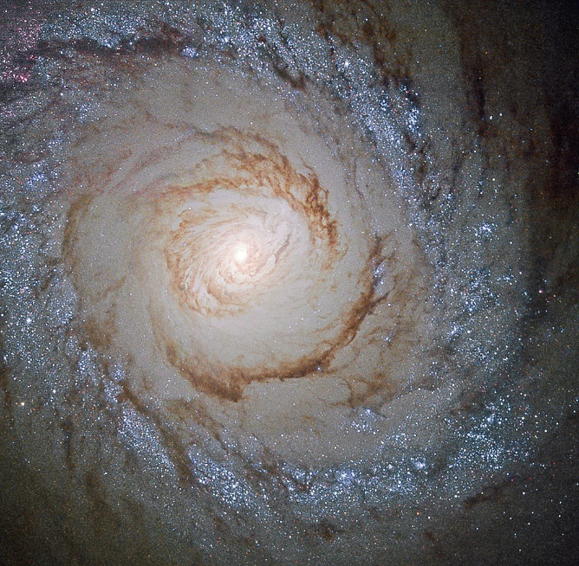 | Spiral galaxy  AD 11.2 × 9.1 moa  AM 8.99  Dist. 16.0 ± 1.3 Mly (4.91 ± 0.40 Mpc)  HRV 308 km/s  RS 0.001027  GCV 360 km/s | 14,700–17,300 | Canes Venatici | 9.0 | 12h 50m 53.1s | +41° 07′ 14″
M95 | NGC 3351 | – | 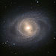 | Barred Spiral galaxy | 31,200–34,000 | Leo | 11.4 | 10h 43m 57.7s | +11° 42′ 14″
M96 | NGC 3368 | – | 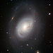 | Spiral galaxy | 28,000–34,000 | Leo | 10.1 | 10h 46m 45.7s | +11° 49′ 12″
M97 | NGC 3587 | Owl Nebula | 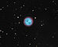 | Planetary nebula | 2.03 | Ursa Major | 9.9 | 11h 14m 47.734s | +55° 01′ 08.50″
M98 | NGC 4192 | – | 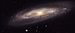 | Spiral galaxy | 44,400 | Coma Berenices | 11.0 | 12h 13m 48.292s | +14° 54′ 01.69″
M99 | NGC 4254 | – | 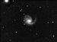 | Spiral galaxy | 44,700–55,700 | Coma Berenices | 10.4 | 12h 18m 49.6s | +14° 24′ 59″
M100 | NGC 4321 | – | 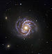 | Spiral galaxy | 55,000 | Coma Berenices | 10.1 | 12h 22m 54.9s | +15° 49′ 21″
M101 | NGC 5457 | Pinwheel Galaxy | 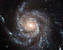 | Spiral galaxy | 19,100–22,400 | Ursa Major | 7.9 | 14h 03m 12.6s | +54° 20′ 57″
M102 | NGC 5866 | Spindle Galaxy | 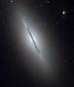 | Lenticular galaxy | 50,000 | Draco | 10.7 | 15h 06m 29.5s | +55° 45′ 48″
M104 | NGC 4594 | Sombrero Galaxy |  | Spiral galaxy | 28,700–30,900 | Virgo | 9.0 | 12h 39m 59.4s | −11° 37′ 23″
M105 | NGC 3379 | – | 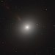 | Elliptical galaxy | 30,400–33,600 | Leo | 10.2 | 10h 47m 49.6s | +12° 34′ 54″
M106 | NGC 4258 | – | 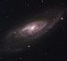 | Spiral galaxy | 22,200–25,200 | Canes Venatici | 9.1 | 12h 18m 57.5s | +47° 18′ 14″
M108 | NGC 3556 | – | 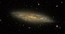 | Barred Spiral galaxy | 46,000 | Ursa Major | 10.7 | 11h 11m 31.0s | +55° 40′ 27″
M109 | NGC 3992 | – | 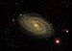 | Barred Spiral galaxy | 59,500–107,500 | Ursa Major | 10.6 | 11h 57m 36.0s | +53° 22′ 28″
M110 | NGC 205 | –

Hvězdokupy
Open cluster – jsou ibecně menší, nejsou gravitačně vázaný (či jsou vázaný jen slabě), …
M11, also known as 'the Wild Duck
Pleiades
Globular cluster – jak napovídá název – jsou kulovitého tvaru, hence take ravitačně vázané,

M2 | NGC 7089 | – | 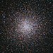 | Globular cluster | 33 | Aquarius | 6.3 | 21^{h} 33^{m} 27.02^{s} | −00° 49′ 23.7″
M3 | NGC 5272 | – | 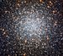 | Globular cluster | 33.9 | Canes Venatici | 6.2 | 13^{h} 42^{m} 11.62^{s} | +28° 22′ 38.2″
M4 | NGC 6121 | – | 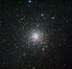 | Globular cluster | 7.2 | Scorpius | 5.9 | 16^{h} 23^{m} 35.22^{s} | −26° 31′ 32.7″
M5 | NGC 5904 | – | 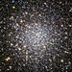 | Globular cluster | 24.5 | Serpens | 6.7 | 15^{h} 18^{m} 33.22^{s} | +02° 04′ 51.7″
M6 | NGC 6405 | Butterfly Cluster | 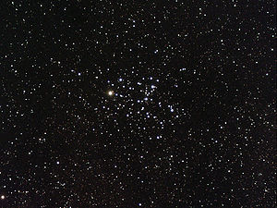 25′ | Open cluster | 1.6 | Scorpius | 4.2 | 17^{h} 40.1^{m} | −32° 13′
M7 | NGC 6475 | Ptolemy Cluster | 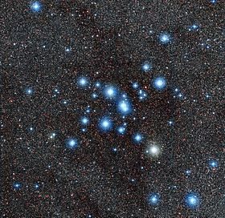 80.0′ | Open cluster | 0.65–1.31 | Scorpius | 3.3 | 17^{h} 53^{m} 51.2^{s} | −34° 47′ 34″
M9 | NGC 6333 | – | 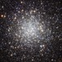 | Globular cluster | 25.8 | Ophiuchus | 8.4 | 17h 19m 11.78s | −18° 30′ 58.5″
M10 | NGC 6254 | – | 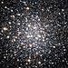 | Globular cluster | 14.3 | Ophiuchus | 6.4 | 16h 57m 8.92s | −04° 05′ 58.07″
M11 | NGC 6705 | Wild Duck Cluster |  | Open cluster | 6.2 | Scutum | 6.3 | 18h 51.1m | −06° 16′
M12 | NGC 6218 | – | 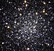 | Globular cluster | 15.7 | Ophiuchus | 7.7 | 16h 47m 14.18s | −01° 56′ 54.7″
M13 | NGC 6205 | Great Globular Cluster in Hercules | 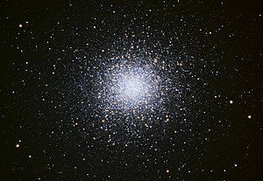 20´ | Globular cluster | 22.2 | Hercules | 5.8 | 16h 41m 41.24s | +36° 27′ 35.5″
M14 | NGC 6402 | – |  | Globular cluster | 30.3 | Ophiuchus | 8.3 | 17h 37m 36.15s | −03° 14′ 45.3″
M15 | NGC 7078 | – | 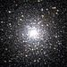 | Globular cluster | 33 | Pegasus | 6.2 | 21h 29m 58.33s | +12° 10′ 01.2″
M18 | NGC 6613 | – |  | Open cluster | 4.9 | Sagittarius | 7.5 | 18h 19.9m | −17° 08′
M19 | NGC 6273 | – |  | Globular cluster | 28.7 | Ophiuchus | 7.5 | 17h 02m 37.69s | −26° 16′ 04.6″
M21 | NGC 6531 | – |  | Open cluster | 4.25 | Sagittarius | 6.5 | 18h 04.6m | −22° 30′
M22 | NGC 6656 | Sagittarius Cluster |  | Globular cluster | 9.6–11.6 | Sagittarius | 5.1 | 18h 36m 23.94s | −23° 54′ 17.1″
M23 | NGC 6494 | – |  | Open cluster | 2.15 | Sagittarius | 6.9 | 17h 56.8m | −19° 01′
M25 | IC 4725 | – |  | Open cluster | 2.0 | Sagittarius | 4.6 | 18h 31.6m | −19° 15′
M26 | NGC 6694 | – |  | Open cluster | 5.0 | Scutum | 8.0 | 18h 45.2m | −09° 24′
M28 | NGC 6626 | – | 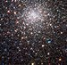 | Globular cluster | 17.9 | Sagittarius | 7.7 | 18h 24m 32.89s | −24° 52′ 11.4″
M29 | NGC 6913 | Cooling Tower |  | Open cluster | 7.2 | Cygnus | 7.1 | 20h 23m 56s | +38° 31′ 24″
M30 | NGC 7099 | – | 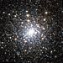 | Globular cluster | 27.8–31 | Capricornus | 7.7 | 21h 40m 22.12 | −23° 10′ 47.5″
M34 | NGC 1039 | – |  | Open cluster | 1.5 | Perseus | 5.5 | 02h 42.1m | +42° 46′
M35 | NGC 2168 | – |  | Open cluster | 2.8 | Gemini | 5.3 | 06h 09.1m | +24° 21′
M36 | NGC 1960 | – |  | Open cluster | 4.1 | Auriga | 6.3 | 05h 36m 12s | +34° 08′ 4″
M37 | NGC 2099 | – |  | Open cluster | 4.511 | Auriga | 6.2 | 05h 52m 18s | +32° 33′ 02″
M38 | NGC 1912 | Starfish Cluster |  | Open cluster | 4.2 | Auriga | 7.4 | 05h 28m 42s | +35° 51′ 18″
M39 | NGC 7092 | – |  | Open cluster | 0.8244 | Cygnus | 5.5 | 21h 31m 42s | +48° 26′ 00″
M40 | – | Winnecke 4 |  | Double star | 0.51 | Ursa Major | 9.7 | 12h 22m 12.5s | +58° 4′ 59″
M41 | NGC 2287 | – | 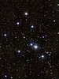 | Open cluster | 2.3 | Canis Major | 4.5 | 06h 46.0m | −20° 46′
M44 | NGC 2632 | Beehive Cluster or Praesepe | 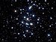 | Open cluster | 0.577 | Cancer | 3.7 | 08h 40.4m | +19° 59′
M45 | – | Pleiades | 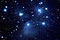 | Open cluster | 0.39–0.46 | Taurus | 1.6 | 03h 47m 24s | +24° 07′ 00″
M46 | NGC 2437 | – |  | Open cluster | 5.4 | Puppis | 6.1 | 07h 41.8m | −14° 49′
M47 | NGC 2422 | – |  | Open cluster | 1.6 | Puppis | 4.2 | 07h 36.6m | −14° 30′
M48 | NGC 2548 | – |  | Open cluster | 1.5 | Hydra | 5.5 | 08h 13.7m | −05° 45′
M50 | NGC 2323 | – |  | Open cluster | 3.2 | Monoceros | 5.9 | 07h 03.2m | −08° 20′
M52 | NGC 7654 | – |  | Open cluster | 5.0 | Cassiopeia | 5.0 | 23h 24.2m | +61° 35′
M53 | NGC 5024 | – | 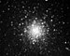 | Globular cluster | 58 | Coma Berenices | 8.3 | 13h 12m 55.25s | +18° 10′ 05.4″
M54 | NGC 6715 | – | 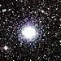 | Globular cluster | 87.4 | Sagittarius | 8.4 | 18h 55m 03.33s | −30° 28′ 47.5″
M55 | NGC 6809 | – | 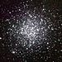 | Globular cluster | 17.6 | Sagittarius | 7.4 | 19h 39m 59.71s | −30° 57′ 53.1″
M56 | NGC 6779 | – | 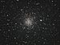 8,8´ | Globular cluster | 32.9 | Lyra | 8.3 | 19h 16m 35.57s | +30° 11′ 00.5″
M62 | NGC 6266 | – |  | Globular cluster | 22.2 | Ophiuchus | 7.4 | 17h 01m 12.60s | −30° 06′ 44.5″
M67 | NGC 2682 | – |  | Open cluster | 2.61–2.93 | Cancer | 6.1 | 08h 51.3m | +11° 49′
M68 | NGC 4590 | – | 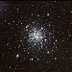 | Globular cluster | 33.6 | Hydra | 9.7 | 12h 39m 27.98s | −26° 44′ 38.6″
M69 | NGC 6637 | – |  | Globular cluster | 29.7 | Sagittarius | 8.3 | 18h 31m 23.10s | −32° 20′ 53.1″
M70 | NGC 6681 | – | 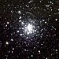 | Globular cluster | 29.4 | Sagittarius | 9.1 | 18h 43m 12.76s | −32° 17′ 31.6″
M71 | NGC 6838 | – |  | Globular cluster | 13.0 | Sagitta | 6.1 | 19h 53m 46.49s | +18° 46′ 45.1″
M72 | NGC 6981 | – |  | Globular cluster | 53.40–55.74 | Aquarius | 9.4 | 20h 53m 27.70s | −12° 32′ 14.3″
M73 | NGC 6994 | – | 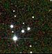 | Asterism | ~2.5 | Aquarius | 9.0 | 20h 58m 54s | −12° 38′
M75 | NGC 6864 | – |  | Globular cluster | 67.5 | Sagittarius | 9.2 | 20h 06m 04.75s | −21° 55′ 16.2″
M79 | NGC 1904 | – | 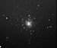 | Globular cluster | 41 | Lepus | 8.6 | 05h 24m 10.59s | −24° 31′ 27.3″
M80 | NGC 6093 | – | 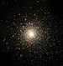 | Globular cluster | 32.6 | Scorpius | 7.9 | 16h 17m 02.41s | −22° 58′ 33.9″

M92 | NGC 6341 | – | 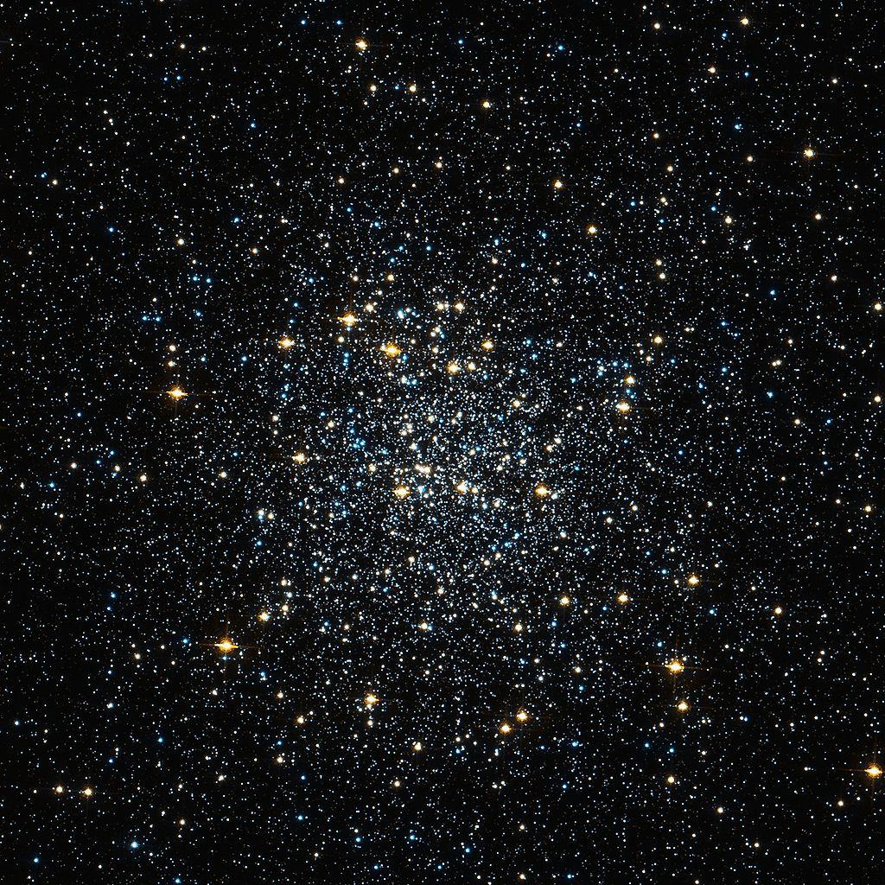 | Globular cluster  14´ | 26.7 | Hercules | 6.3 | 17h 17m 07.39s | +43° 08′ 09.4″
M93 | NGC 2447 | – | 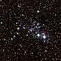 | Open cluster | 3.6 | Puppis | 6.0 | 07h 44.6m | −23° 52′
M103 | NGC 581 | – |  | Open cluster | 10 | Cassiopeia | 7.4 | 01h 33.2m | +60° 42′
M107 | NGC 6171 | – | 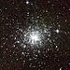 | Globular cluster | 20.9 | Ophiuchus | 8.9 | 16h 32m 31.86s | −13° 03′ 13.6″

